**1. INTRODUCTION**

**1.1 OVERVIEW**

**Analysis of Future Loan Eligibility Using IBM Cognos**

Dream Housing Finance company deals in all home loans. They have a presence across all urban, semi-urban, and rural areas.  Customer – First applies for a Home Loan, after that company validates the eligibility by building own model to predict the eligibility.

Company wants to automate the Loan Eligibility Process in a real time scenario with the detail provided while applying application for home loan.  
   
We will try to build a model using data from loan applications.

**1.2 PURPOSE**

**Project Objectives**

* Know fundamental concepts and can work on IBM Cognos Analytics
* Gain a broad understanding of plotting different graphs.
* Creating relevant dashboards.

**2. LITURATURE SURVEY**

**2.1 EXSISTING PROBLEM**

Dream Housing Finance company deals in all home loans. They have a presence across all urban, semi-urban, and rural areas.  Customer – First applies for a Home Loan, after that company validates the eligibility by building own model to predict the eligibility.

Company wants to automate the Loan Eligibility Process in a real time scenario with the detail provided while applying application for home loan.  
   
We will try to build a model using data from loan applications.

**2.2 PROPOSED SOLUTION**

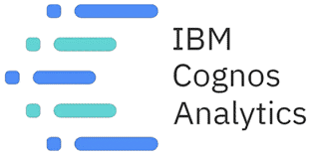

IBM Cognos Analytics is a business intelligence solution that empowers users with AI-infused self-service capabilities that accelerate data preparation, analysis, and report creation.

This tutorial will showcase Cognos Analytics on IBM Cloud Pak for Data. This version of Cognos Analytics contains AI-infused features, such as:

* An embedded natural language assistant that allows you to ask a question about your data to gain quick insights.
* A forecasting tool to discover and model trend, seasonality, and time dependence in your data.
* Insight analysis that can help detect and validate any important relationships and meaningful differences in individual visualizations.

**3. THEORETICAL ANALYSIS**

**3.1 BLOCK DIAGRAM**

**Technical Architecture**

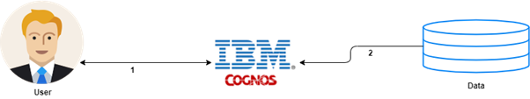

**3.2 HARDWARE/SOFTWARE DESIGNING**

**IBM CLOUD**

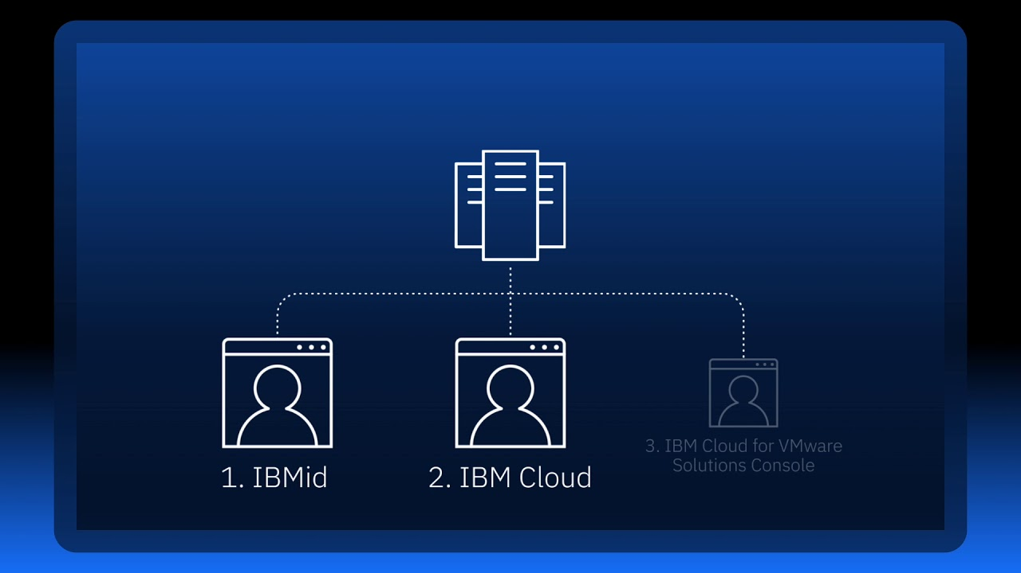

IBM Cloud offers the most open and secure public cloud for business, a next-generation hybrid multi-cloud platform, advanced data and AI capabilities, and deep enterprise expertise across 20 industries.

A full stack cloud platform with over 170 products and services covering data, containers, AI, IoT, and Blockchain. Use your existing infrastructure-even edge or other public clouds-with IBM Cloud services, APIs, access policies, security controls and compliance with IBM Cloud Satellite.

**IBM COGNOS ANALYTICS**



One BI solution can do it all: clean and connect your data, create stunning visualizations, and show you where your business is today while helping predict what will happen tomorrow.

**4. EXPERIMENTAL INVESTIGATION**

### Understand the Dataset

Let us try to understand about each field of the data.

|  |  |
| --- | --- |
| **Key Name** | **Description** |
| Loan_ID | Unique Loan ID |
| Gender | Male/ Female |
| Married | Applicant married (Y/N) |
| Dependents | Number of dependents |
| Education | Applicant Education (Graduate/ Under Graduate) |
| Self_Employed | Self-employed (Y/N) |
| ApplicantIncome | Applicant income |
| CoapplicantIncome | Co-applicant income |
| LoanAmount | Loan amount in thousands |
| Loan_Amount_Term | Term of a loan in months |
| Credit_History | credit history meets guidelines |
| Property_Area | Urban/ Semi-Urban/ Rural |
| Loan_Status | Loan approved (Y/N) |

### Loading the Dataset

Before you can build a view and analyses of your data, you must first connect the data to IBM Cognos. Cognos supports connecting to a wide variety of data, stored in a variety of places.

The data might be stored on your computer in a spreadsheet or a text file, or in a big data, relational, or cube (multidimensional) database on a server in your enterprise.  
  
In our case, we will be using a spreadsheet or text file for making our analysis.

**5. PROJECT FLOW**

**Project Flow**

* Users create multiple analysis graphs/charts.
* Using the analysed chart creation of Dashboard is done.
* Saving and visualizing the final dashboard in the IBM Cognos Analytics.

To accomplish this, we have to complete all the activities and tasks listed below:

* IBM Cloud Account.
* Login to Cognos Analytics.
* Working with the Dataset.
* Understanding the Dataset.
* Loading the Dataset.

**Data Visualization Charts.**

Building of Visualizations with Analysis based on Data distribution.

* Gender distribution
* Distribution of marriage by gender
* Distribution of education by gender, marriage
* Distribution of self employed by gender
* Average, min, max applicant income by self-employed
* Location of the houses
* Income of the applicants distributed according to the location of the houses
* Loan Amount of the applicants distributed according to the location of the houses
* Credit History Distribution
* Credit history related to applicant income, loan amount, loan amount term

**6. RESULT**

**Data Visualization Charts**

Using the given dataset, let us explore data analytics which refers to the critical process of performing initial investigations on data so as to discover patterns, to spot anomalies, to test hypothesis and to check assumptions with the help of summary statistics and graphical representations.

The easiest way of understanding data is by focusing on data and decide which graph, transformation to make suitable visualizations.

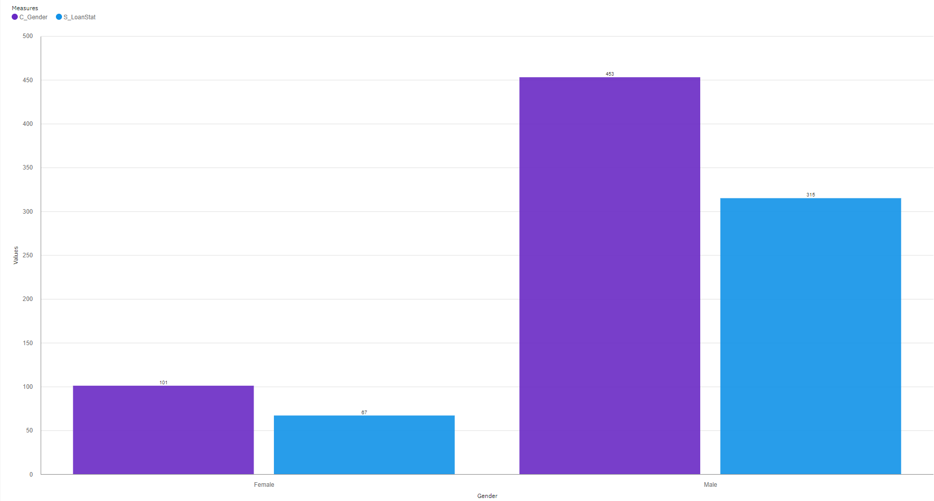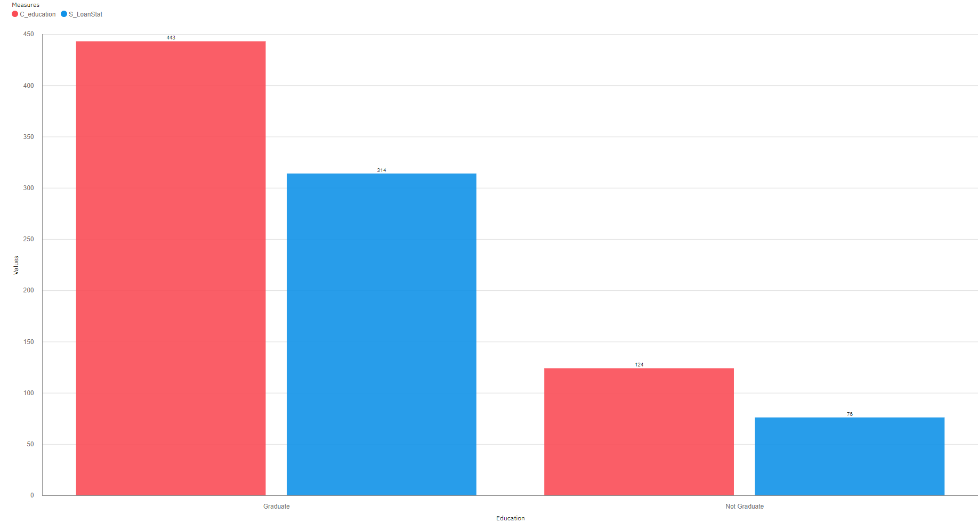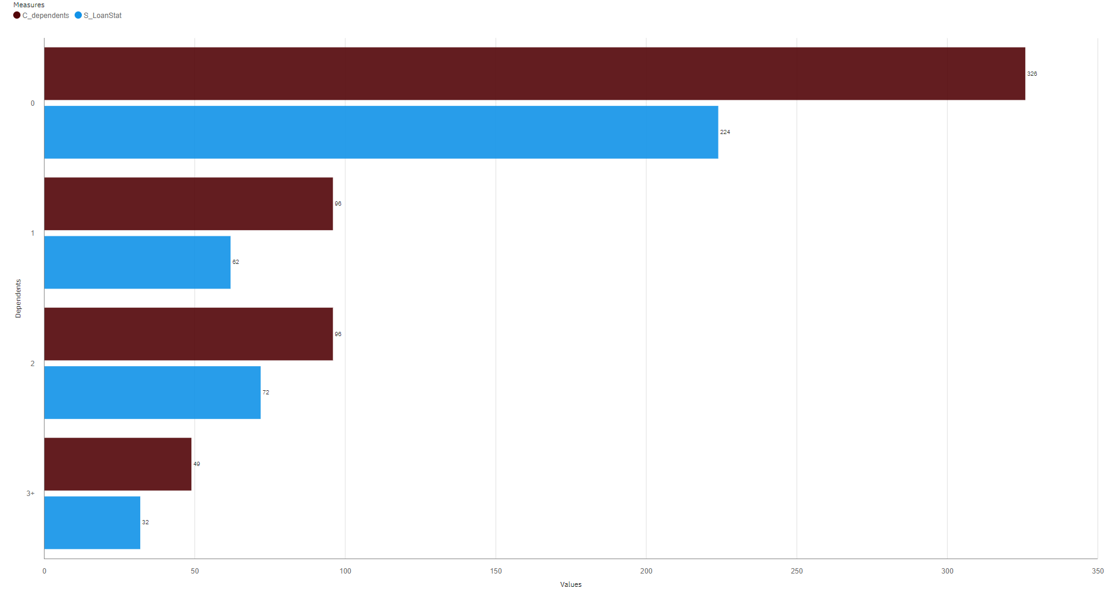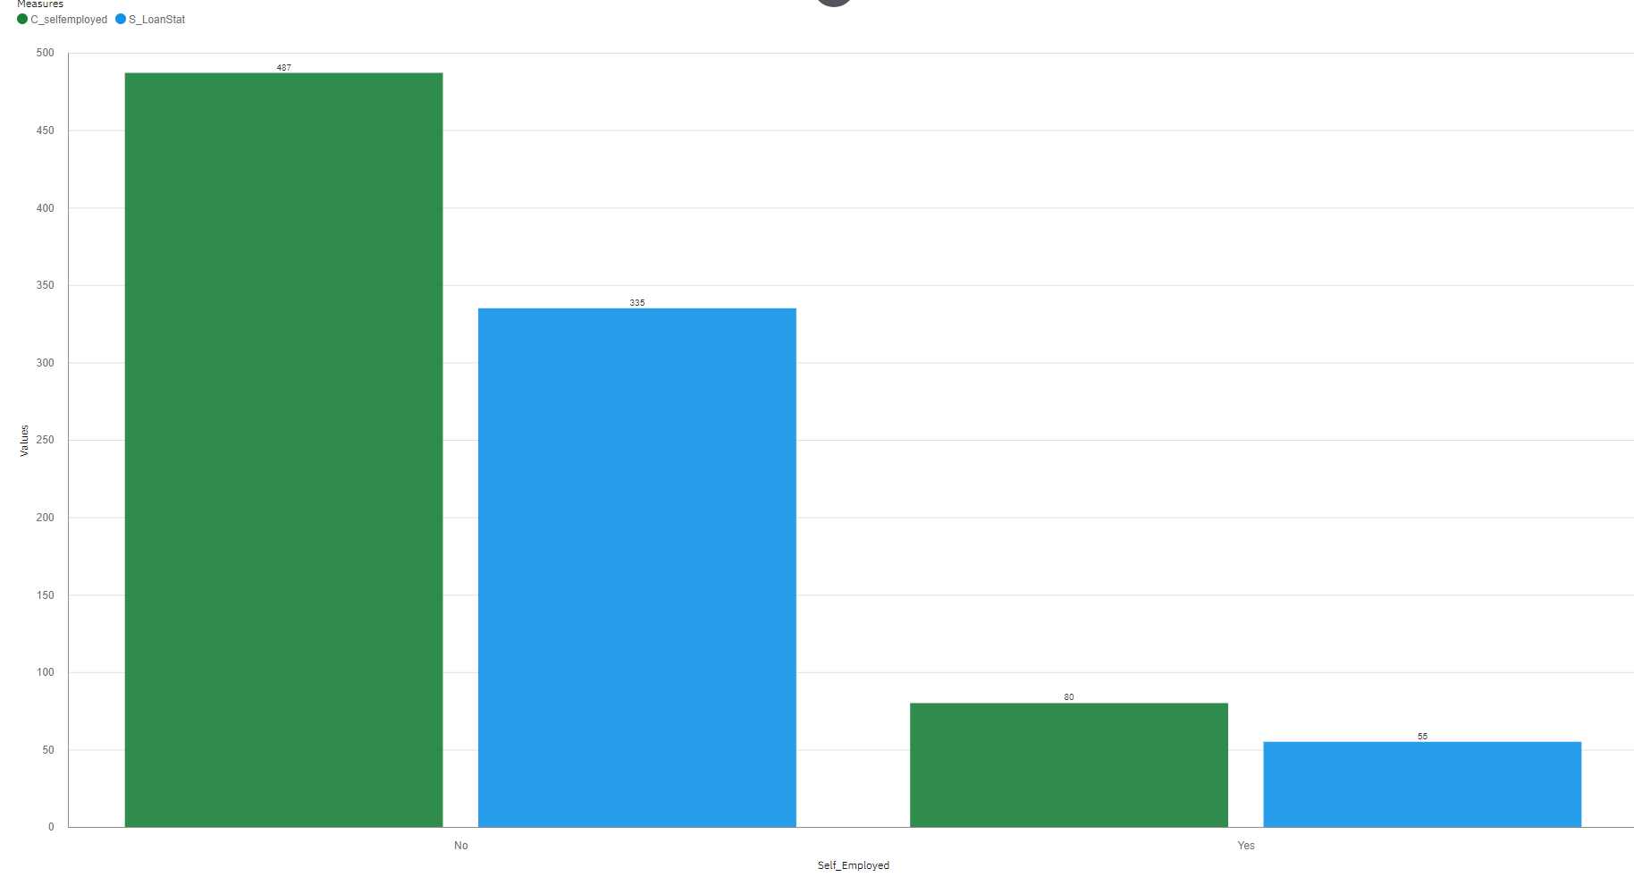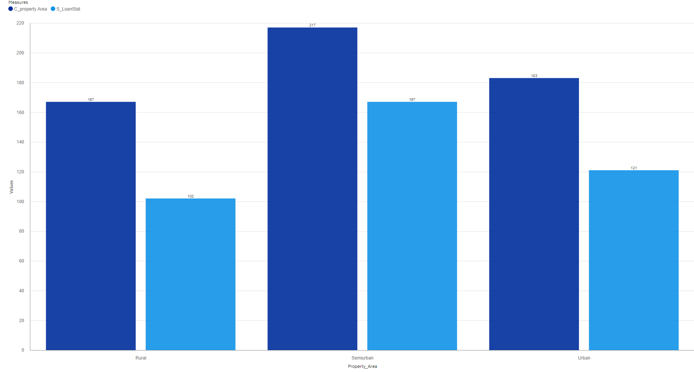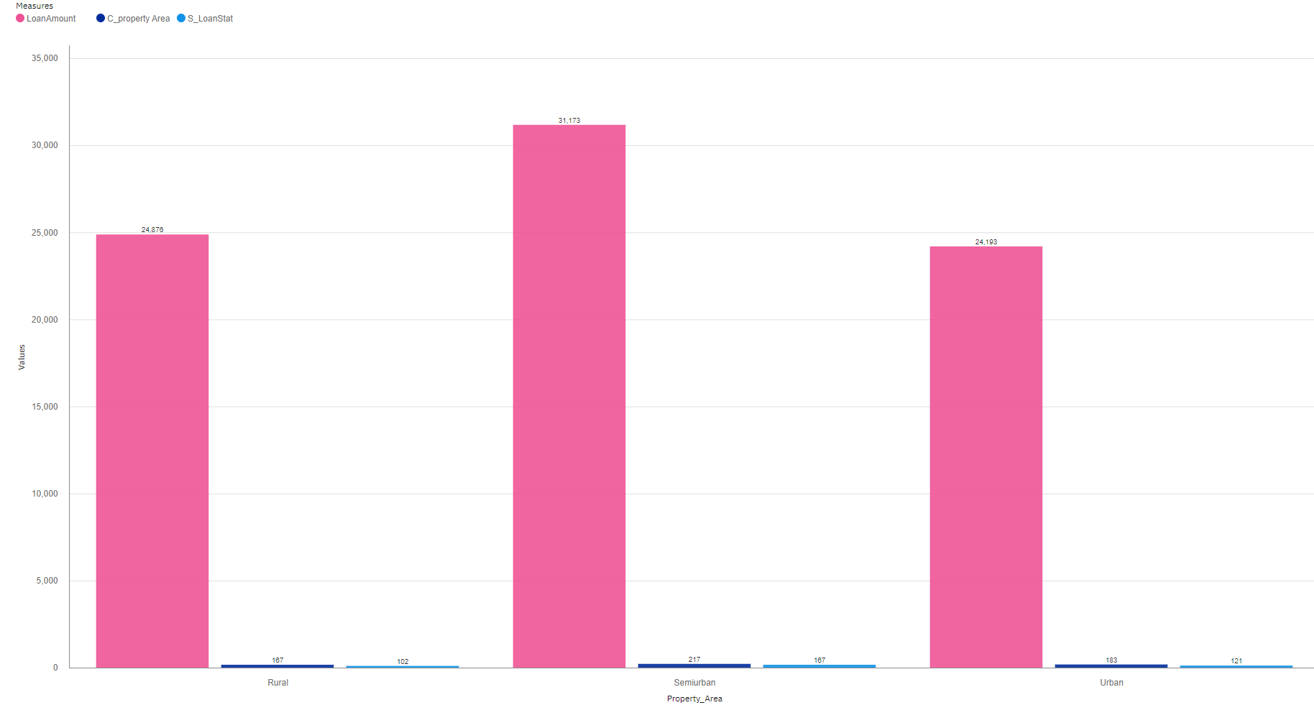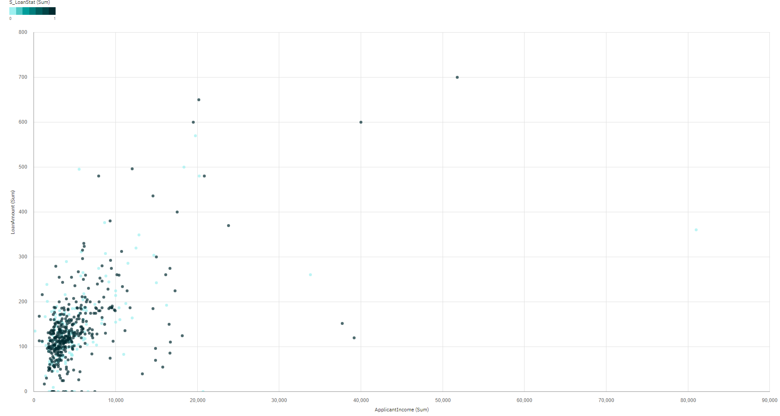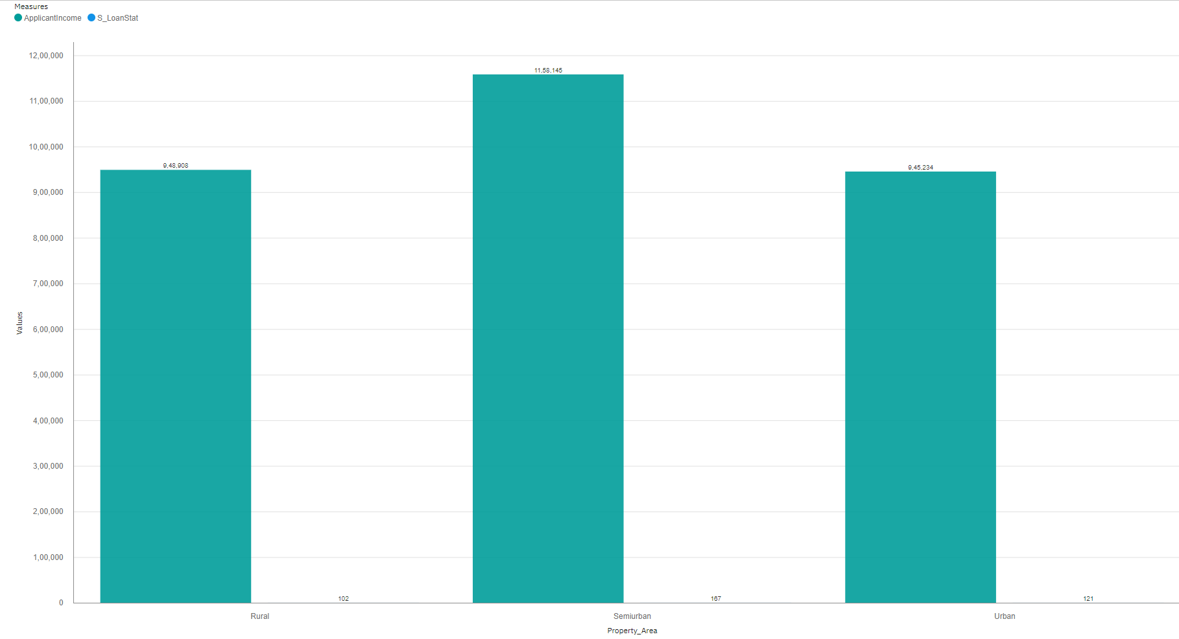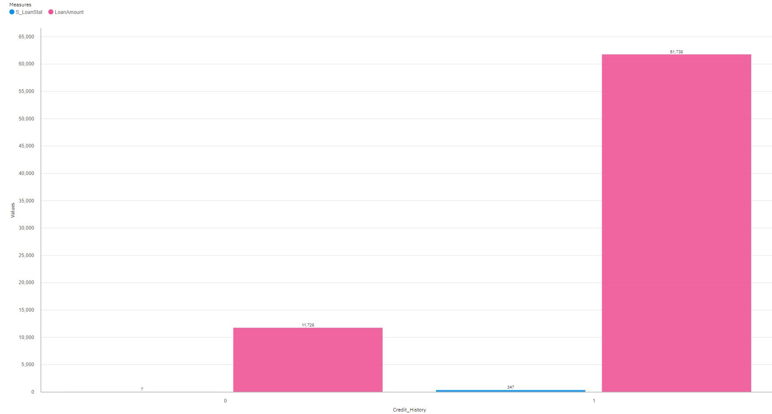

**7. ADVANTAGES AND DISADVANTAGES**

**ADVANTAGES**

* **Multiple analysis tools:**

What if analysis;

Trend analysis;

Advanced analysis;

Analytical reporting.

* **Self-service functionality**:

Enables working offline or on mobile devices.

* **Interactive operation for multiple users.**
* **Integration with other APIs.**
* **Interactive dashboard, friendly user interfaces.**
* **Interactive operation for multiple users.**

**DISADVANTAGES**

* **Relatively high entry cost compared to other similar software products.**
* **Not designed for beginner or inexperienced users.**
* **Difficult error tracking as error messages contain little useful information.**
* **Large installer compared to other similar software product.**

**8. APPLICATIONS**

The reasons are long and detailed, but simply put, some high level reasons not to build reporting systems off of normalized databases are:

* Query performance
* General production system performance
* Aggregate view of data vs transactional view
* Complex SQL
* Normalized databases are typically tuned for simple queries.

With IBM-Cognos’s long history in this area, they have often heard feedback surrounding this classic problem.  We believe, that IBM’s Analytical Application Framework (AAF), provides a good foundation to begin to solve this problem.

As a result AAF customers can:

* Meet business change head on- to change as fast as your business does
* Minimize your IT departments role in constantly managing the application
* Ensuring that the application’s content is continuously relevant
* Optimizing the TCO of the applications

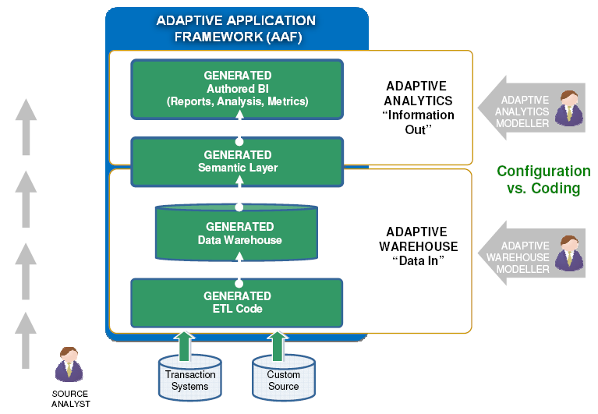

**9. CONCLUSION**

By this proposed work, we came to know about fundamental concepts and how can we work on IBM Cognos Analytics, gaining of a broad understanding of plotting different graphs and how to create a meaningful dashboards.

The present visualisations

### Eligibility by Gender

### Eligibility by Martial Status

### Eligibility by Educational Status

### Eligibility Based On Dependents

### Eligibility Based On Self Employment Status

### Eligibility Based On Property Area

### Eligibility Based On Property Area & Loan Amount

### Eligibility Based On Income & Loan Amount

### Eligibility Based On Applicant Income & Property Area

### Eligibility Based On Loan Amount & Credit History

### 10. BIBLIOGRAPHY APPENDIX

### Data Set:

### <https://www.kaggle.com/vikasukani/loan-eligible-dataset>

### Research:

### <https://www.researchgate.net>

### <https://www.ironsidegroup.com>

### <https://www.ibm.com/in-en/products/cognos-analytics>

### <https://www.ibm.com/in-en/cloud>

### Tools:

### <https://cloud.ibm.com> (IBM Cloud)

### <https://www.ibm.com/in-en/products/cognos-analytics> (IBM Cognos Analytics)

### <https://github.com> (Git Repository)

### <https://smartinternz.com> (Project Site)